**LATIHAN SESI 06 – DATABASE**

Nama : Abraham Haholongan Narmada Pohan

Kode : FSDO002ONL010

A. CREATE DATABASE staff;

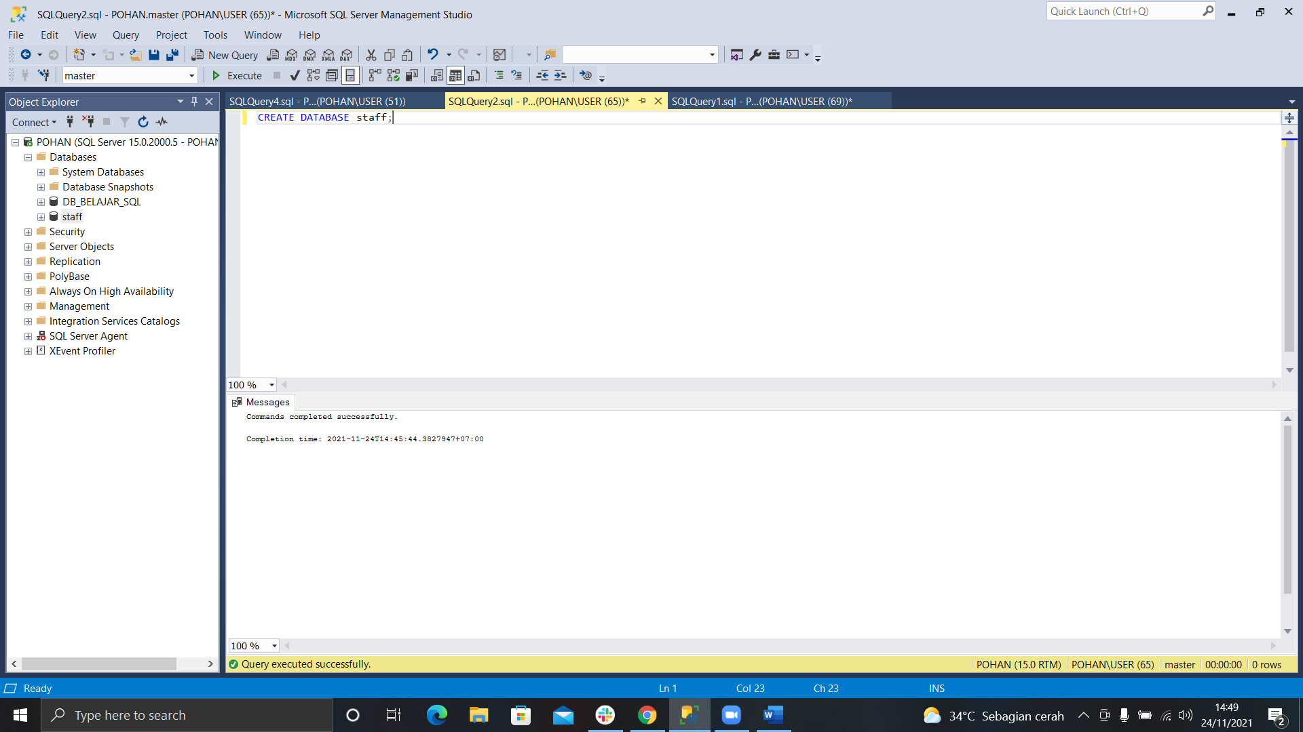

B. CREATE TABLE data_staff(

nik INT PRIMARY KEY,

nama VARCHAR(50) NULL,

alamat VARCHAR(200) NULL,

handphone VARCHAR(15) NULL

);

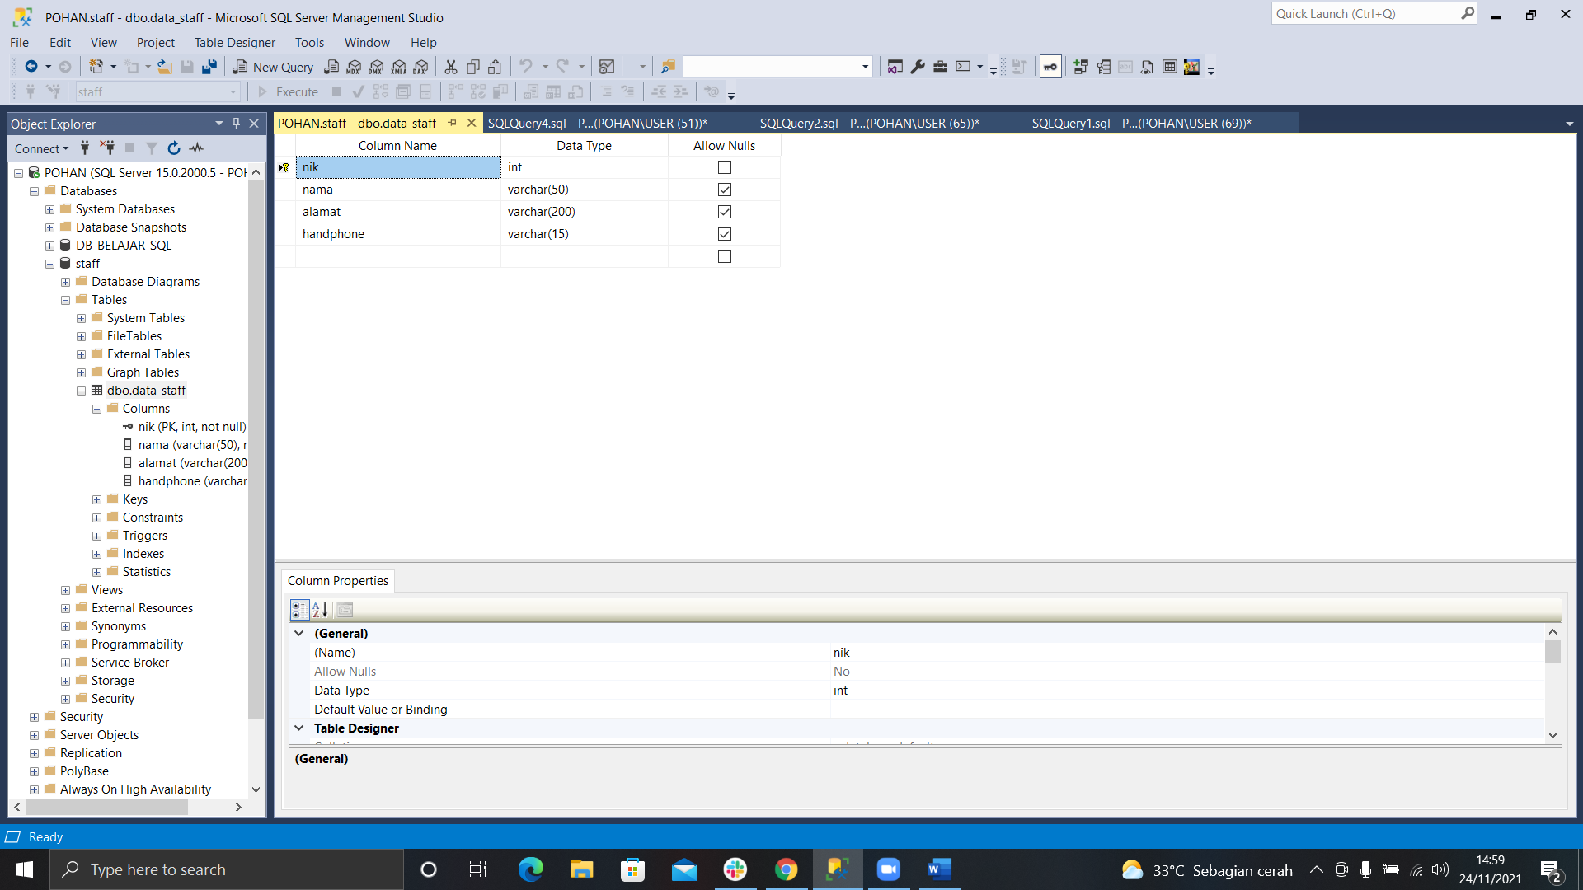

C. INSERT INTO data_staff (nik, nama, alamat, handphone) VALUES(001, 'Pohan', 'Surabaya', '14045');

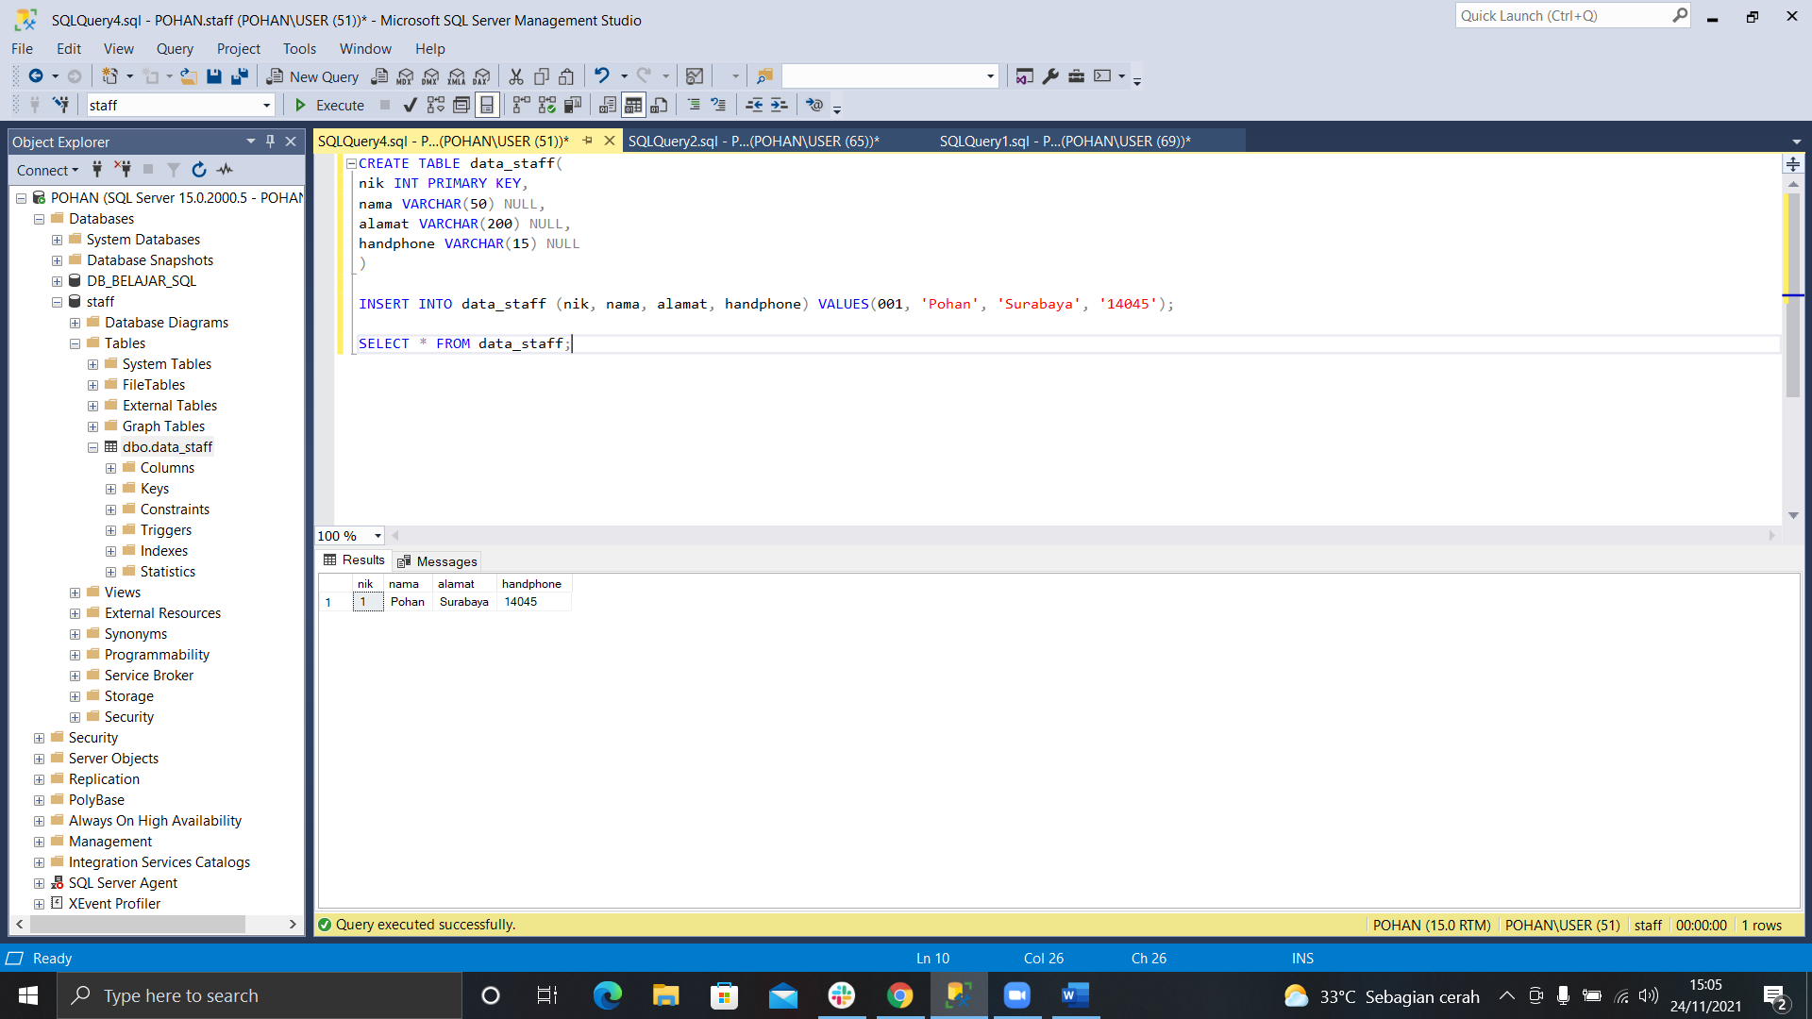

D. INSERT INTO data_staff (nik, nama, alamat, handphone) VALUES(002, 'Tantra', 'Sidoarjo', '007009');

INSERT INTO data_staff (nik, nama, alamat, handphone) VALUES(003, 'Rahmanda', 'Malang', '150802');

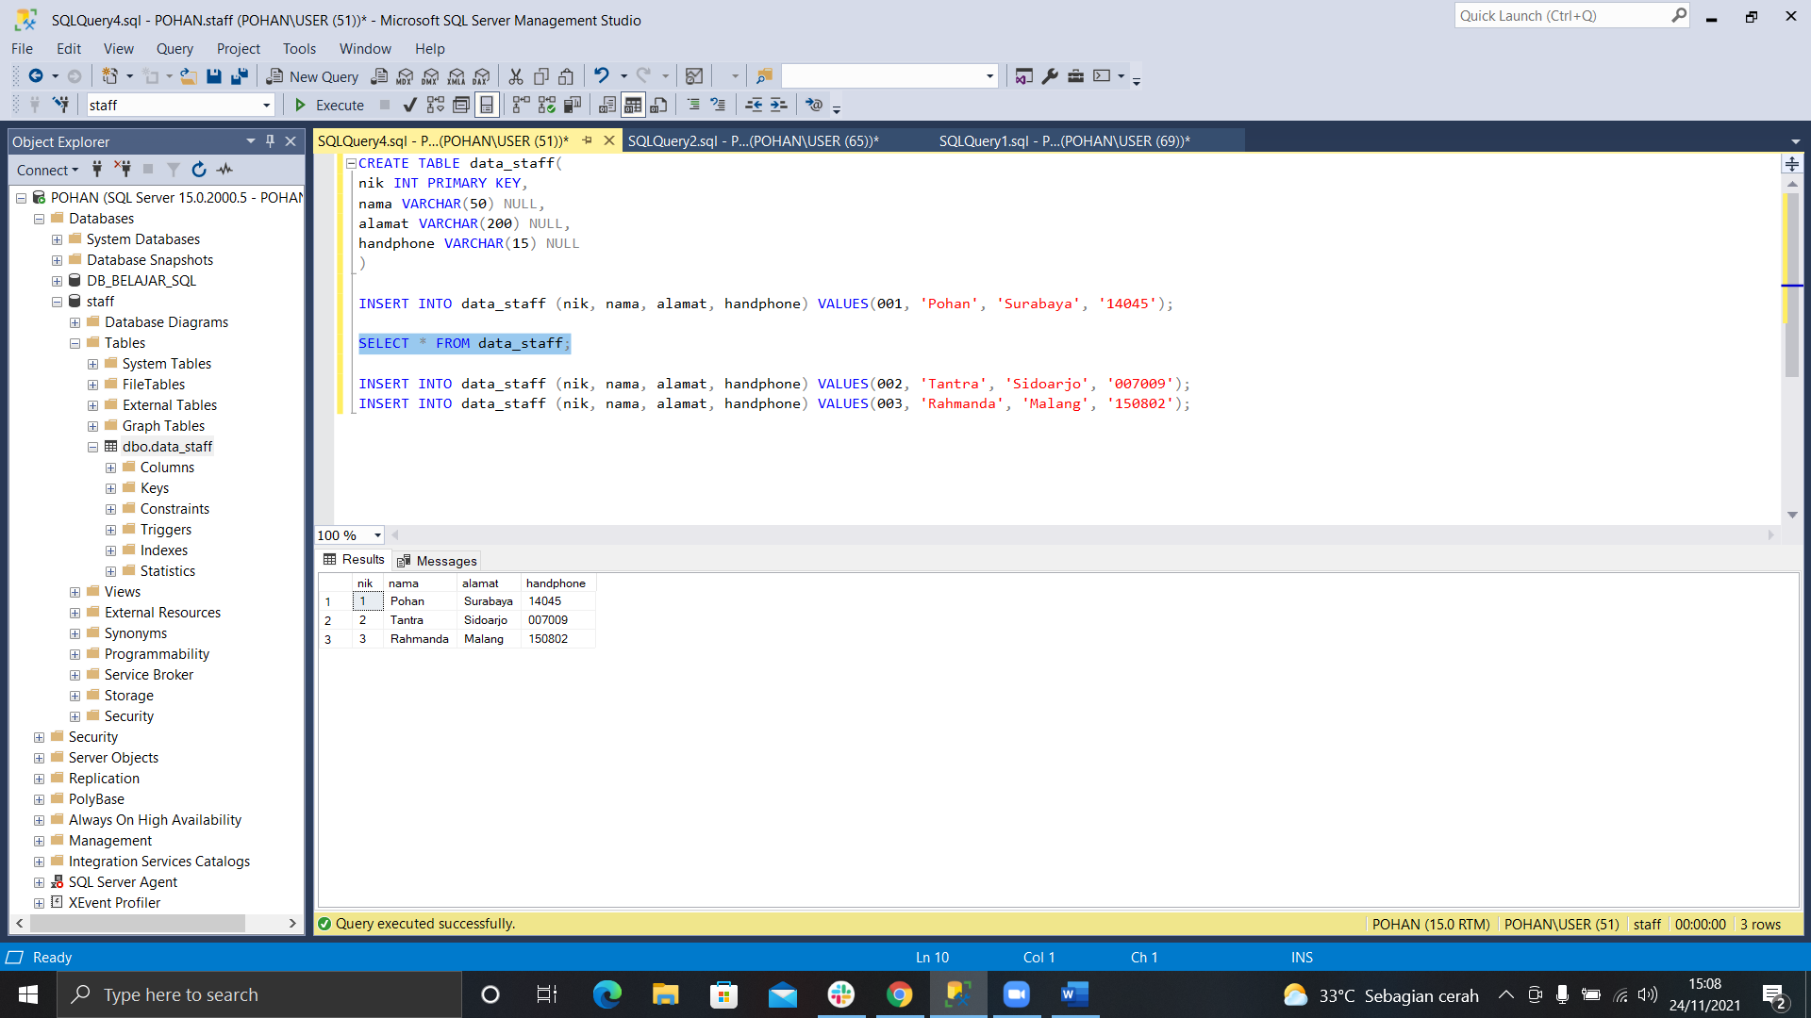

E. INSERT INTO data_staff (nik, nama, alamat, handphone, joindate) VALUES(004, 'Junior', 'Bandung', '08785555', '2021-11-24');

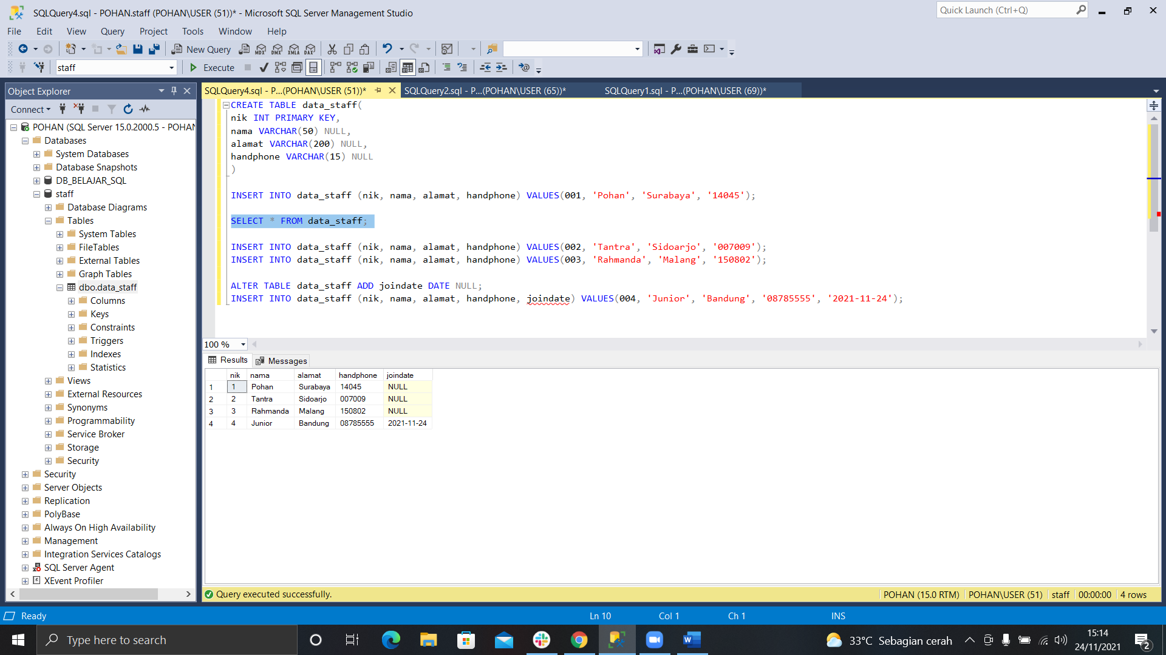

F. SELECT TOP 2 * FROM data_staff;

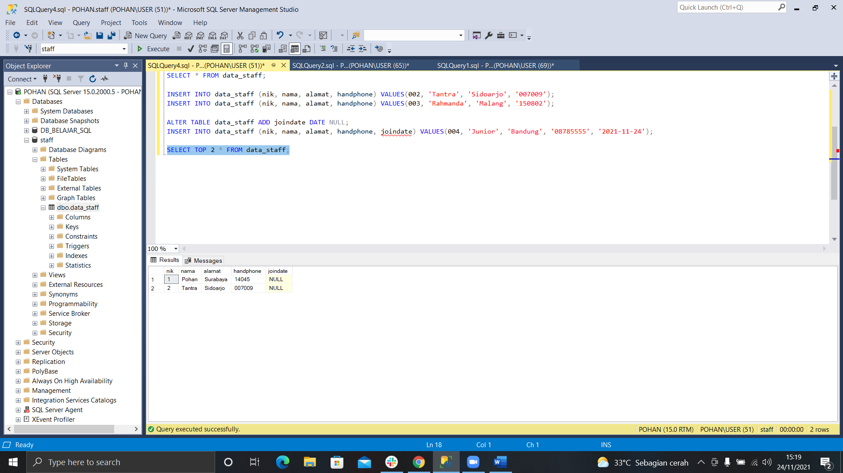

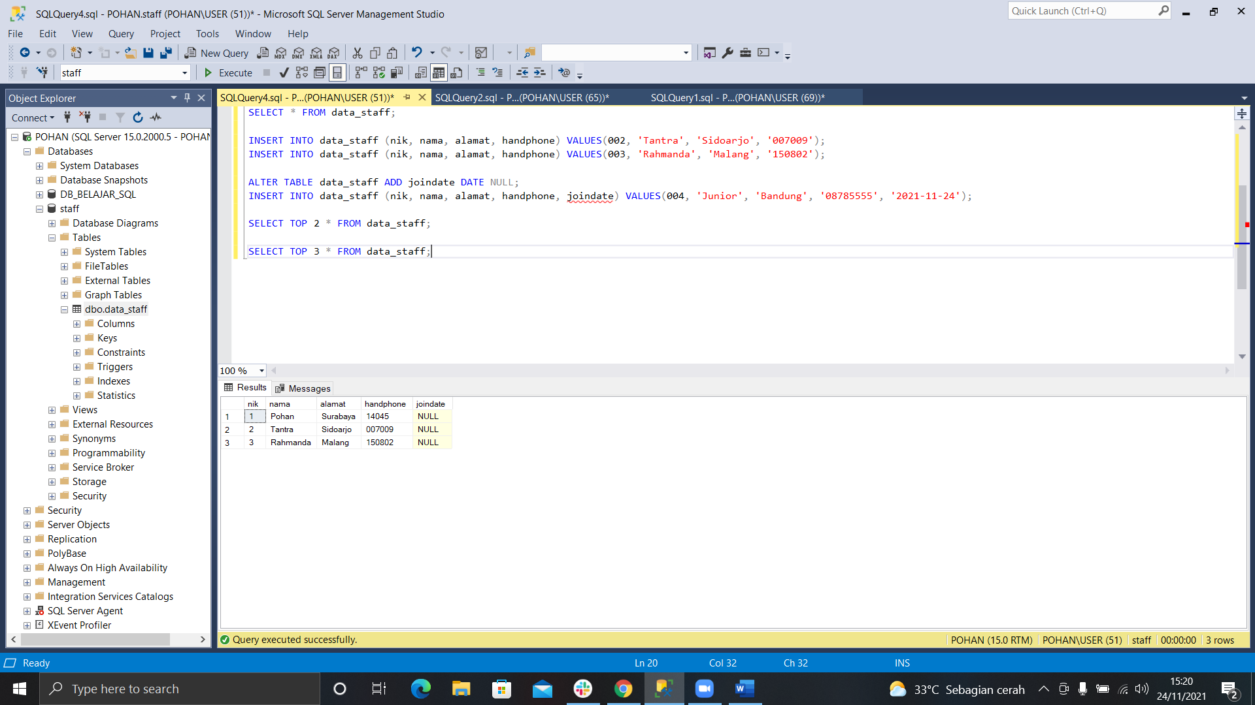G. SELECT TOP 3 * FROM data_staff;

H. CREATE TABLE staffoutsource(

nik INT PRIMARY KEY,

nama VARCHAR(50) NULL,

alamat VARCHAR(200) NULL,

handphone VARCHAR(15) NULL

)

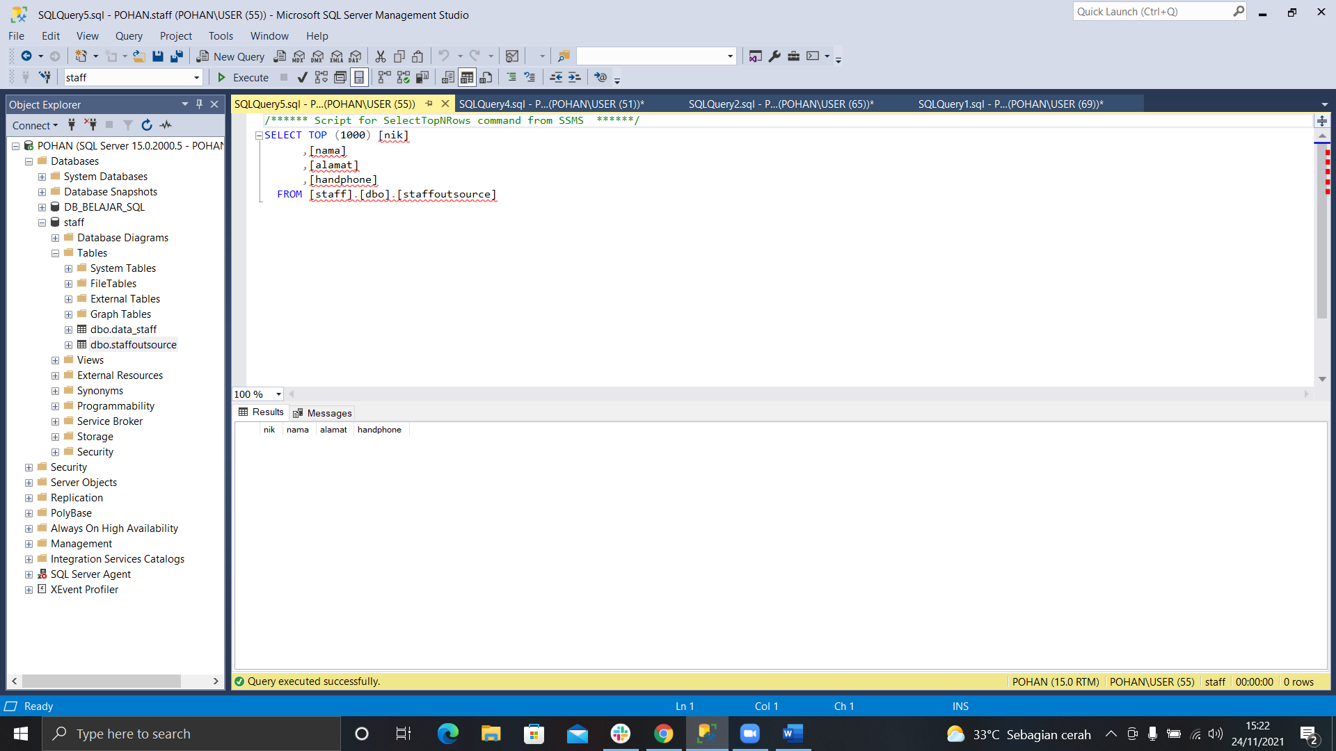

I. INSERT INTO staffoutsource (nik, nama, alamat, handphone, joindate) VALUES(001, 'Namira', 'Bandung', '1232131', '2021-11-24');

INSERT INTO staffoutsource (nik, nama, alamat, handphone, joindate) VALUES(002, 'Cyndya', 'Surabaya', '234234234', '2021-11-22');

INSERT INTO staffoutsource (nik, nama, alamat, handphone, joindate) VALUES(003, 'Erica', 'Malang', '324234324', '2021-11-24');

INSERT INTO staffoutsource (nik, nama, alamat, handphone, joindate) VALUES(004, 'Jinjin', 'Batu', '34534534', '2021-11-20');

INSERT INTO staffoutsource (nik, nama, alamat, handphone) VALUES(005, 'Fariska', 'Jombang', '14565454');

INSERT INTO staffoutsource (nik, nama, alamat, handphone, joindate) VALUES(006, 'Anam', 'Pasuruan', '3242342', '2021-11-25');

INSERT INTO staffoutsource (nik, nama, alamat, handphone) VALUES(007, 'Oding', 'Surabaya', '1232445');

INSERT INTO staffoutsource (nik, nama, alamat, handphone, joindate) VALUES(008, 'Angga', 'Malang', '12454546', '2021-11-20');

INSERT INTO staffoutsource (nik, nama, alamat, handphone) VALUES(009, 'Triko', 'Nganjuk', '1234567777');

INSERT INTO staffoutsource (nik, nama, alamat, handphone, joindate) VALUES(010, 'Daus', 'Bandung', '1232445533', '2021-11-24');

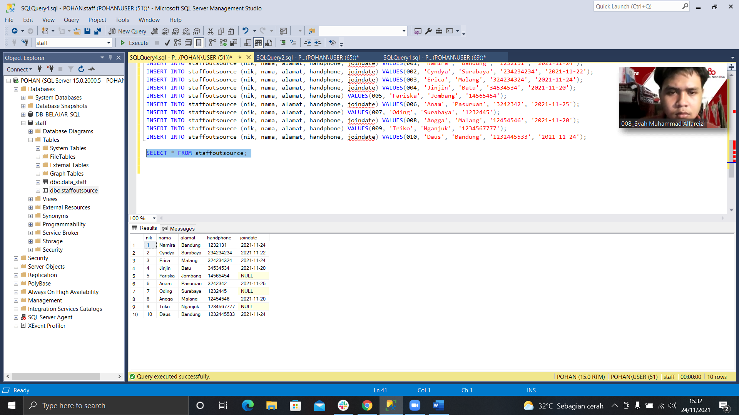

J. SELECT * FROM data_staff dt INNER JOIN staffoutsource so ON dt.joindate = so.joindate;

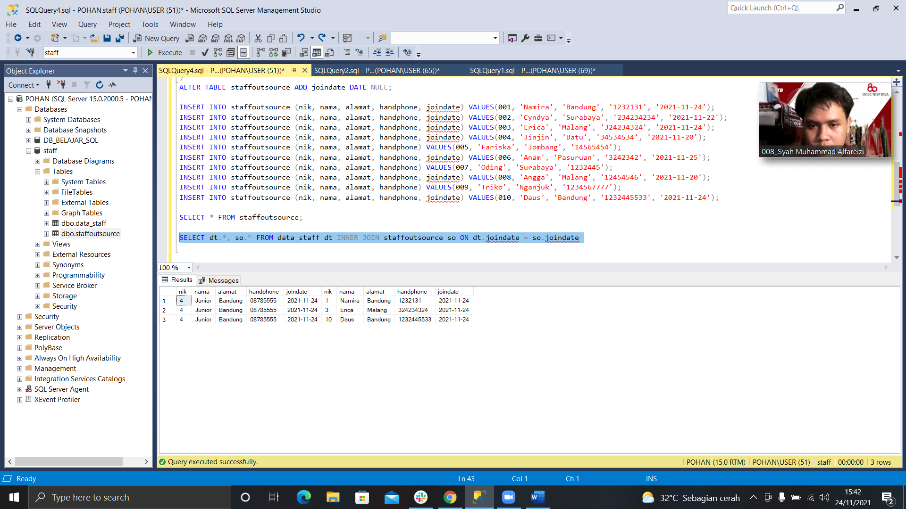

K. SELECT * FROM data_staff dt RIGHT JOIN staffoutsource so ON dt.joindate = so.joindate;

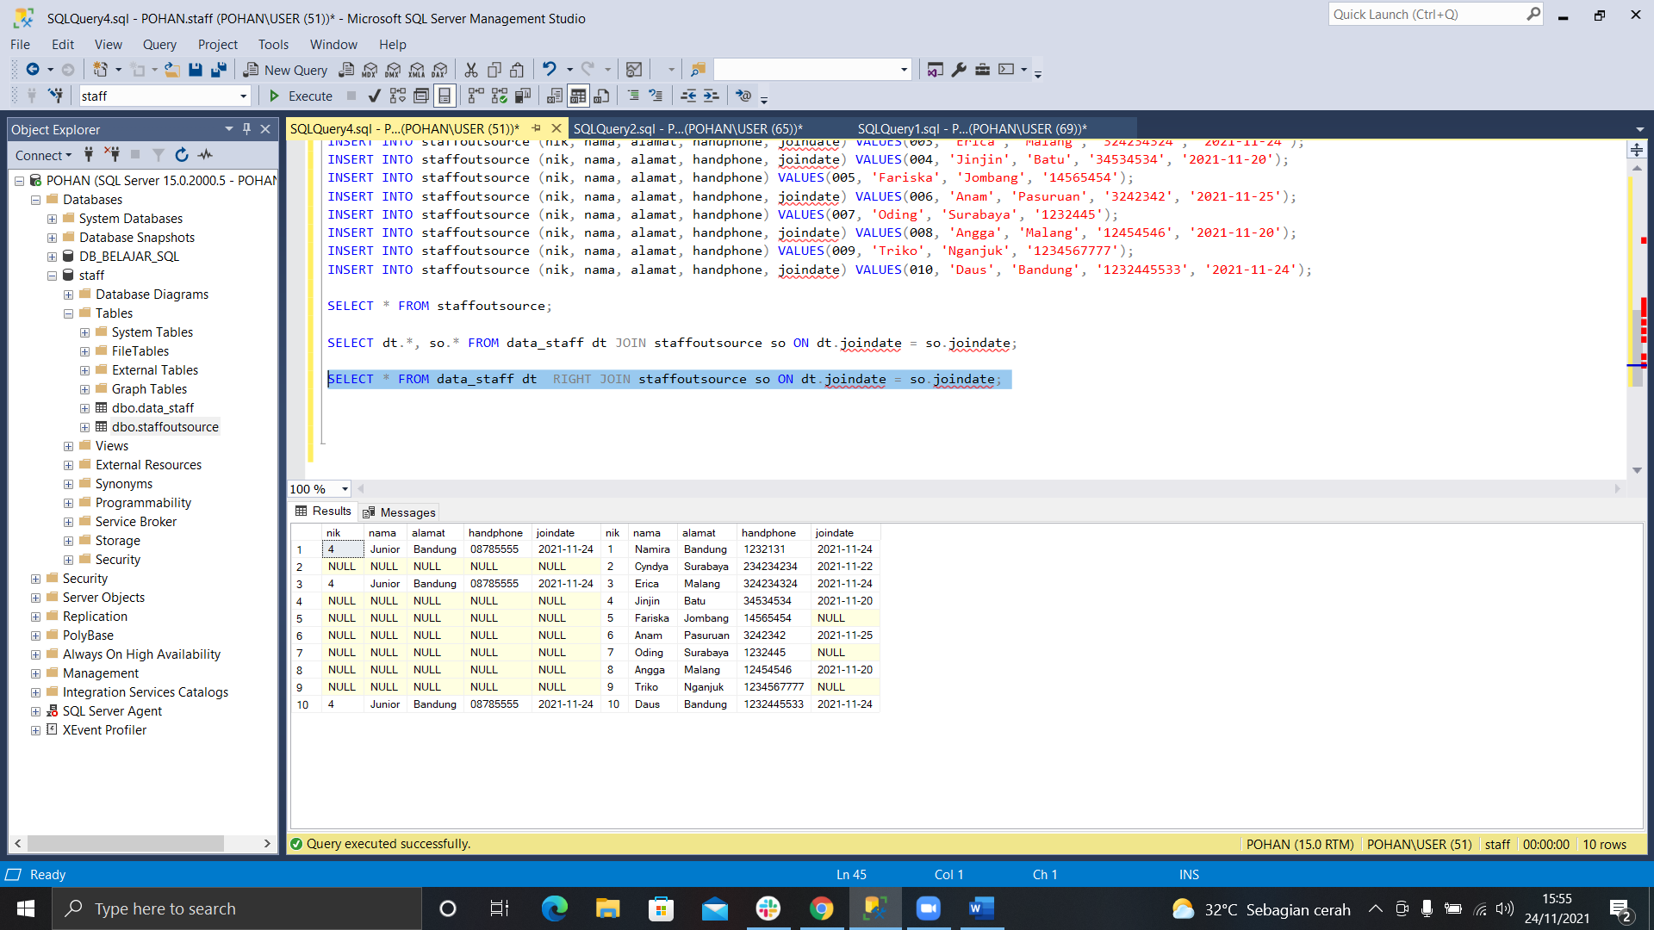

L. SELECT * FROM data_staff dt LEFT JOIN staffoutsource so ON dt.joindate = so.joindate;

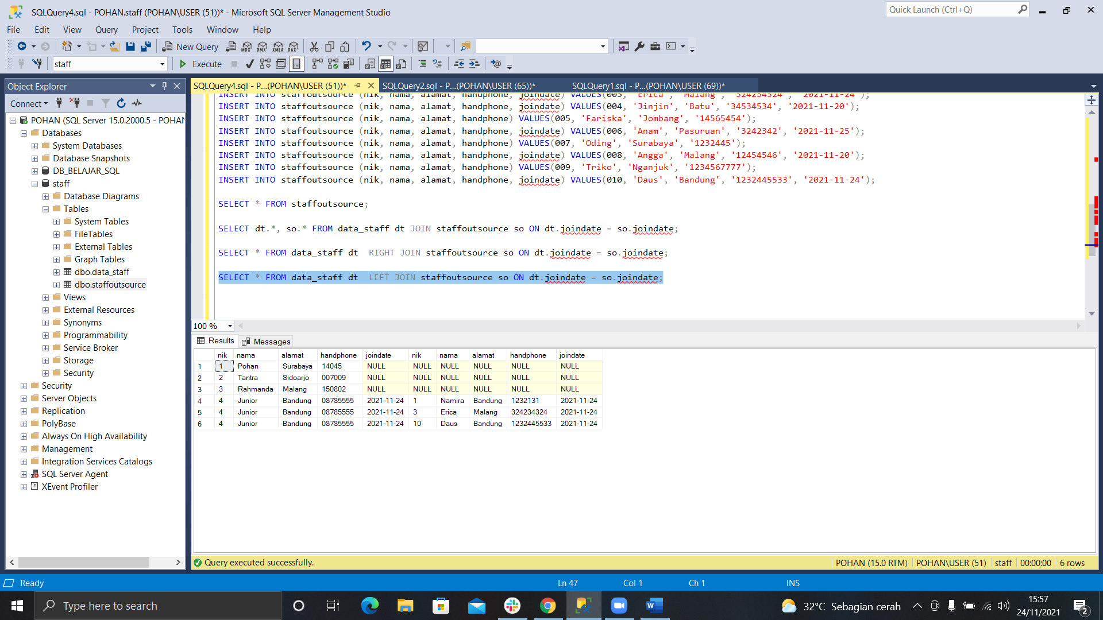

M. SELECT * FROM data_staff UNION SELECT * FROM staffoutsource;

